PRODUCT DETAILS

**Casio Casio Collection Watch MWD-100HD-1AVEF**

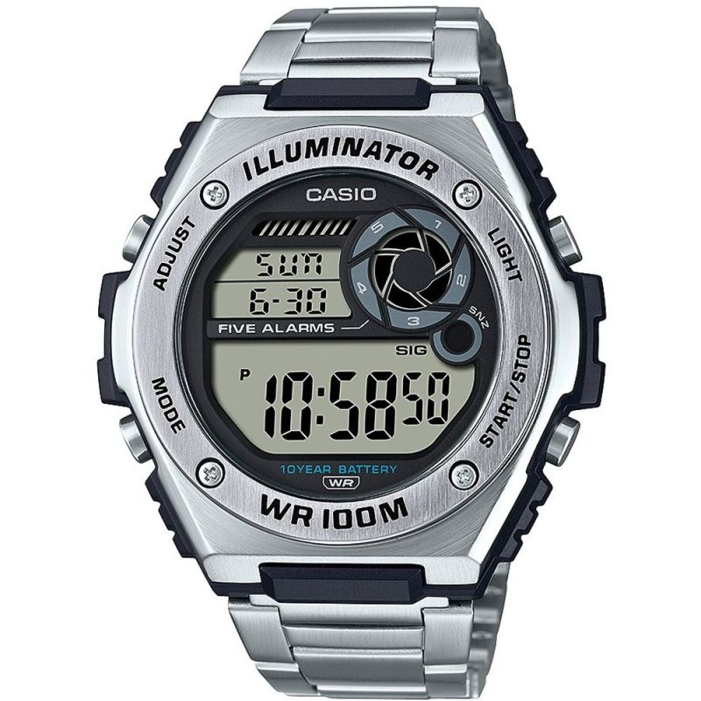

**£49.00**

**Specifications**

**Brand**: Casio

**Alarm**: Yes

**Analogue/Digital**: Digital

**Backlight**: Yes

**Case depth approx**.: 14.00mm

**Primary Material**: Stainless Steel

**Case Shape**: Circle

**Case width approx**.: 51.00mm

**Chronograph**: Yes

**Clasp type**: Clasp

**Dial Colour**: Black

**Multiple Time Zones Display**: None

**Gender**: Gents

**Glass**: Acrylic

**Luminescent hands**: Yes

**Model Collection**: Collection

**Model Name**: Collection

**Movement Source**: Japan

**Movement**: Quartz

**Strap colour**: Silver

**Strap Type**: Metal bracelet

**Water Resistance**: 100 metres

**Weight (g)**: 111.00

**BARCODE**: 4549526273391

**Guarantee**: 2 YEARS

**Country of Origin Code**: CH